
Visit Cincinnati
Cincinnati is a city in and the county seat of Hamilton County, Ohio, United States. Settled in 1788, the city is located on the north bank of the Ohio River at the Ohio–Kentucky border, near Indiana. Cincinnati is home to two major sports teams, the Cincinnati Reds and the Cincinnati Bengals.

Activities

T
here are several things you can do here in Cincinnati such as:

- Cincinnati Zoo & Botanical Garden
- Cincinnati Reds Hall of Fame
- Eden Park
- National Underground Railroad Freedom Center
- Full Throttle Indoor Karting
- Paul Brown Stadium (Bengals)
- Coco Key Water Resort
- Great American Ballpark (Reds)
- Harriet Beecher Stowe House
All of these locations are popular places for family fun and relaxing. Whether Sports, animals, or plants are your main interest Cincinnati is the place for you.

Travel Arrangements
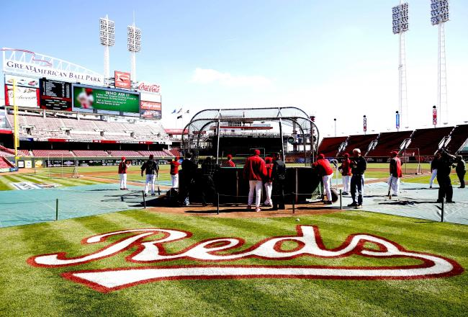
The Westin Hotel is a well-known hotel in Cincinnati. The total for 2 nights at the hotel would be $499.58. Your Plane will take off from Indianapolis and will fly to Chicago, shortly after that, it will fly to CVG Airport in Cincinnati for $615 per person. A rental car from “Dollar Rental” will be waiting for $65.55 per day.
Itinerary

Thursday | Cincinnati Zoo & Botanical Garden, Eden Park, and Coco Key Water Resort
Friday | Cincinnati Reds Hall of Fame, Paul Brown Stadium, and Full Throttle Indoor Karting
Saturday | Harriet Beecher Stowe House and National Underground Railroad Freedom Center

