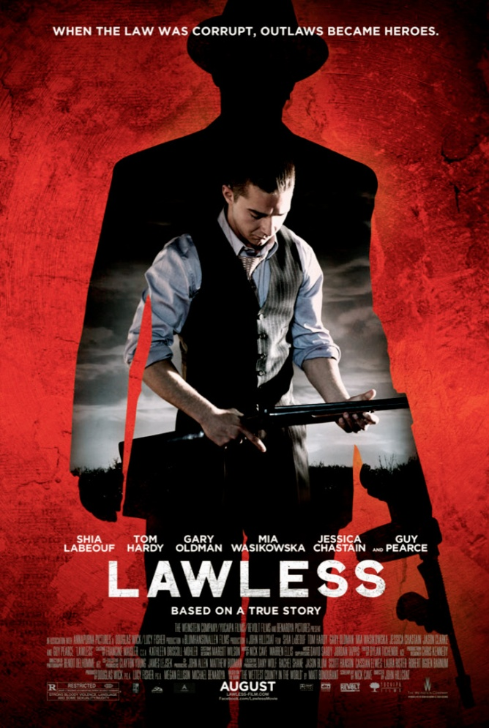
LAWLESS
John Hillcoat’s Lawless
Expectations are murder. With a dynamite cast, an iconic screenwriter in rocker Nick Cave and an Aussie director in John Hillcoat, who inspired worship for The Proposition, you assume a new classic. What you get is an ambitious try. As the summer dribbles to a close with formula pap, you could do worse.

Read more: http://www.rollingstone.com/movies/reviews/lawless-20120830#ixzz2Khqq3Z7V
Follow us: @rollingstone on Twitter | RollingStone on Facebook
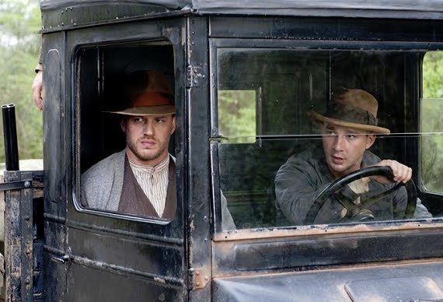
Page Title

Location

Lawless was filmed early 2011 in various locations near Atlanta, Georgia, including Newnan, Grantville, Haralson, LaGrange, Carroll County's McIntosh Park, and the Red Oak Creek Covered Bridge.
“They call Franklin the Wettest County in the world on account of almost everybody makin' the stuff.” – Matthew Bondurant

Actors
Tom Hardy, Shia LaBeouf, Jessica Chastain, Guy Pearce, Gary Oldman

Funding
Director John Hillcoat says he has still difficulty getting funding for the films he likes to make: “The state of things are pretty tough as everyone here knows, particularly in my world, which is the kind of medium budget (range).
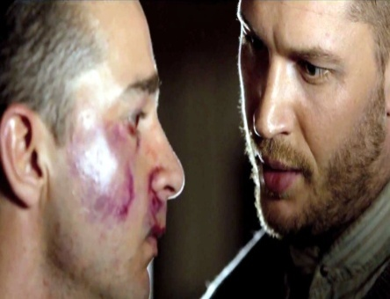
Also, there are films that have character and drama and those words that you cannot use in the United States at this time,” said Hillcoat. But while many great dramas are picked up by TV networks like HBO instead of movie companies at the moment, the Australian director still managed to get the funding for Lawless – which has the backing of the Weinstein Company.

Lawless Soundtrack

Cave and Ellis recorded punk-bluegrass versions of songs, including Link Wray's "Fire and Brimstone," Townes Van Zandt's "Fire in the Blood," Captain Beefheart's "Sure 'Nuff Yes I Do" and the Velvet Underground's "White Light/White Heat."

