Nick Waggoner
3/14/2013
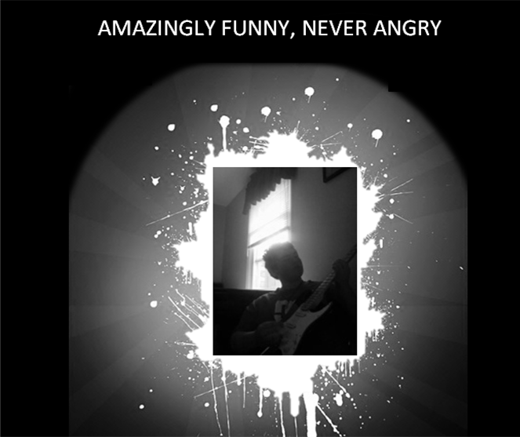 | 1234 Clarks Road Panama City, FL  (123)456 - 7890  N/A  www.nickwaggoner.yolasite.com

Education
Floyd Central High School

I am currently in progress for the International Baccalaureate diploma program. I have won awards from Rauch Inc. for an essay, invitations from the National Youth Leadership Council to attend a meeting on medicine, I have received letters from Yale, Evansville, Southern Illinois, Northern Kentucky, Western Kentucky, Georgia Tech, Indiana University – Purdue University of Indianapolis, and the University of Indianapolis.
experience
Student | Floyd Central High School

I have been in Orchestra at Floyd Central since 2011 in which I play the cello. I do community service at my church in Palmyra, Indiana. I volunteer at my mom’s salon in New Albany, Indiana. I have refereed games at HYR’s baseball park. I play baseball every summer at HYR. I have worked several church picnics. I have done community service for Indiana’s Department of Child Services. I have completed several fundraiser walks for cancer funds. More specifically a 5 mile walking marathon in Paoli, Indiana.
skills
- Hardworking
- Leader
- Gets along well with others
- Untiring
- Completes everything
- Perfectionist
- Focused
- Structured
- Punctual

